US Grade 9 – Pre-test
15 Questions | 60 minutes | Calculator allowed
1. Make $I$the subject in the formula $A=P+I$
- $I=A+P$
- $I=P-A$
- $I=A/P$
- $I=A-P$

2. Find the missing term in the sequence.
-2, 6, -18, __________, -162, 496, …
- 24
- 42
- 54
- 62

3. Simplify $\frac{y^{7}×y^{4}}{y^{5}}$
- $y^{5.6}$
- $y^{6}$
- $y^{22}$
- $y^{23}$
4. Rolland and Sammy shared $200 in the ratio 2:3 respectively.
How much did Sammy receive?
- 80
- 100
- 120
- 150

5. Factorise $a(b+1)-2(b+1)$
- $-2a(b+1)$
- $a-2(b+1)$
- $(a-2)(b+1)$
- $a-2(b+1)(b+1)$

6. A man leaves town A and travels West for 80km. He then turns and travels East for 100km.
How far and in what direction is he from town A?
- 20km East
- 20km West
- 30km East
- 30km West

7. A TV screen was selling at a cost of $900 in April. In May the price reduced to $720.
What was the percentage decrease of the price?
- 10%
- 20%
- 30%
- 40%

8. Calculate angle P in the figure shown.
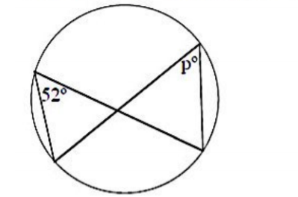
- 20
- 38
- 52
- 90

9. Simplify $[(a^{4}b^{5})^{2}÷(a^{9}b^{7})^{0}]$$÷ab^{2}$
- $b^{16}$
- $a^{2}b^{7}$
- $a^{6}b^{7}$
- $a^{7}b^{8}$

10. The radius of a circle is 6 meters.
What is the area of the sector bounded by a 60 degree arc?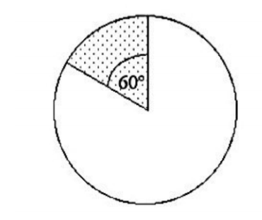
- $6π$
- $π/6$
- $60π$
- $π/60$

11. A cubic storage container as shown in the diagram has side lengths of $3x$ meters.
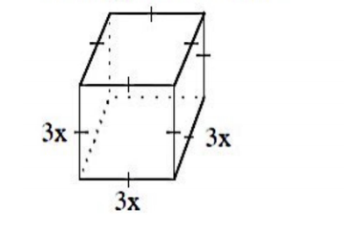
What is the simplified expression for the volume?
- $27x^{3}$
- $27x$
- $9x^{3}$
- $9x$

12. $(8×10^{5})÷(4×10^{-3})$
- $2×10^{8}$
- $2×10^{7}$
- $2×10^{3}$
- $2×10^{2}$

13. Solve for x
$1-$$\frac{x+1}{2 }=0$
- $-3$
- $1$
- $2$
- $3$

14. In an experiment a six-sided die was tossed 90 times.
The results of the tosses are as recoded in the table below.
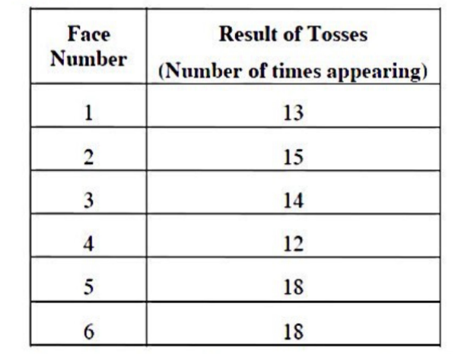
Which Face Number had an experimental probability that matched its expected probability?
- 2
- 3
- 4
- 5

15. Which illustration best describes the graph of $y=1-x^{2}$ ?
